Disengage AD
Schindler CRD Applications

Exported on 2025-10-17 05:00:01

Table of Contents

1 Prerequisite: 4
2 Procedure: 5

- Prerequisite:
- Procedure:

Prerequisite:
- Need admin access on Windchill Application server.

Procedure:
- Take backup of site.xconf file.
- Lookup for the below value in site.xconf file.
com.schindler.global.EnterpriseLdap

3. You will find any one of the below properties.
Property-1:
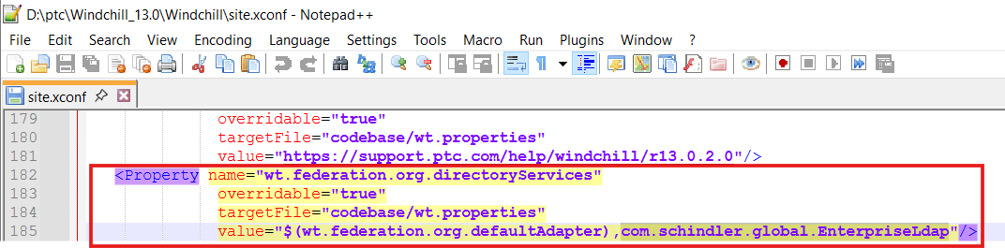
Property-2:
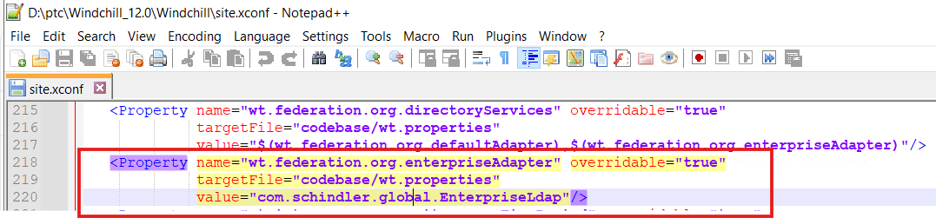

4. If you find the Property-1 then update the property as shown below.
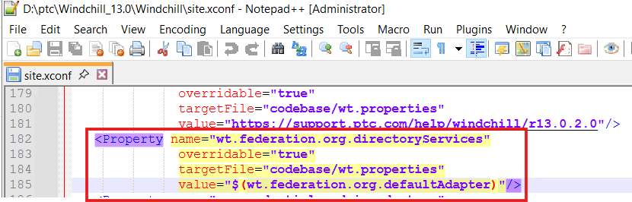

5. If you find the Property-2 then comment the property.
6. Now lookup for the below property.
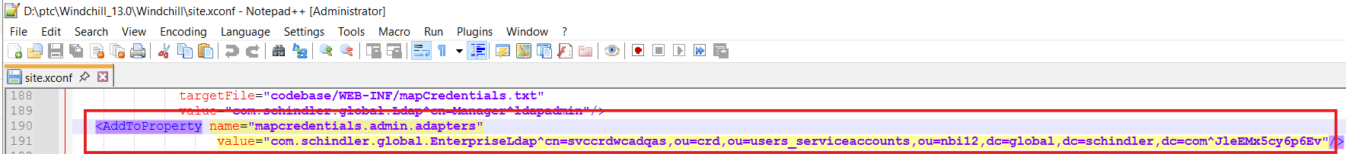

7. Comment out the property as shown below.
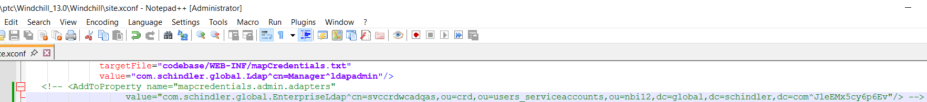

8. Launch Windchill shell as an admin and execute xconfmanager -p as shown below.
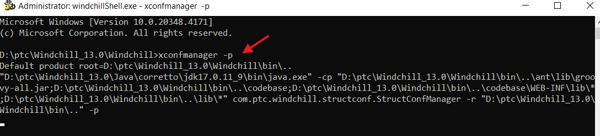

9. Stop Windchill, DS & Apache.
10. Clean cache and start Apache, DS & Windchill.

